|  |
| --- |
| aua-logo-1-05-01-1.png |
| Report |
| The connection between Discount rate and Short-term Government Bond rate |
|  |
|  |
|  |

|  |
| --- |
|  |

Instructor: Vardan Baghdasaryan

Students:

Arman Aleksanyan

Garizeta Chakhoyan

Elen Navasardyan

Vladimir Yesayan

**Abstract**

The main objective of the paper is to use a cointegration approach to analyze how short term government bond rate responds to discount rate’s movements. It can be indicated from the study that discount rate is cointegrated with government rates, which means that the relationship among these two variables is that they share a common unit root process. The reason of choosing these series is the huge impact that stock market has on economic growth.

In addition, an Autoregressive Distributed Lag model (ARDL) has been applied and it can be seen the relationship between the lagged dependent variable and past values of dependent and explanatory variables. Finally, 6-month forecast was done for the short term rate. As the data shows, there will be no considerable changes in the short term Government bond rates for the following 6 months (with 0.04 range).

**Introduction**

As a key component of financial system, stock market plays a crucial role to boost the economic growth of the country. A well functioning stock market is representative of financial strength of any economy. The functioning of stock market depends on a number of economic factors and investors are always keen to know the impact of these factors on stock prices. Among a number of economic variable interest rate is considered to be key one which exerts a significant influence on stock prices. Our paper investigates the cointegration in interest rates and their changes in Armenia. The financial sector of Armenia consists of 19 scheduled commercial banks, 37 Non Banking Financial Institutions (NBFIs), 6 insurance companies, and 1 stock market (NASDAQ OMX Armenia). Financial theory suggests that interest rate is one of the macro economic factors that should systematically affect stock market return (Chen et al., 1986). Thus, interest rate is considered as one of the most significant determinants of the stock prices (Modigliani and Cohn, 1979). This paper attempts to analyze the relationship of government bonds rate with discount rate volatility in Armenia between August 2006 and 2018 March.

**Data**

The purpose of selecting this data, as it was mentioned above, was the importance of stock market and rates on the economy of Armenia. The data includes ‘Monthly rates’ published by Central bank of Armenia and NASDAQ OMX Armenia’s website (nasdaqomx.am). As it can be seen from the correlation table the data are highly correlated. The study investigates the relationship between short-term, mid-term and long-term sovereign bond rates and interest rate. The data set comprises of monthly time series data for Armenia over the total 139 sample periods of August 2006 to March 2018.

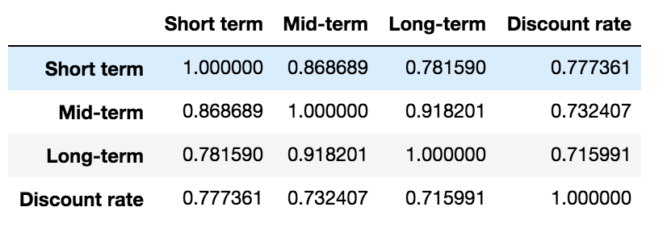Figure-1

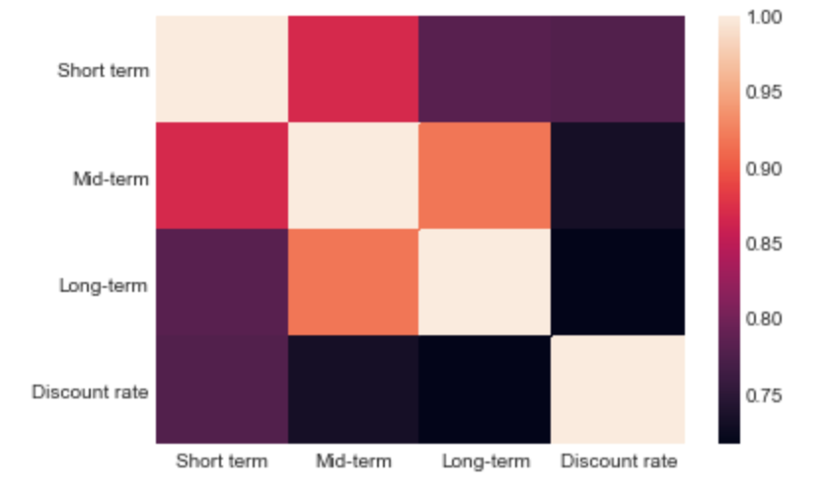Figure-2

As the short-term rate and discount rate have highest correlation we will test the cointegration among these two rates. The pattern of the four rates can be seen from the chart. As we can see their patterns change in the same direction, which means it is logical to test the cointegration between them.

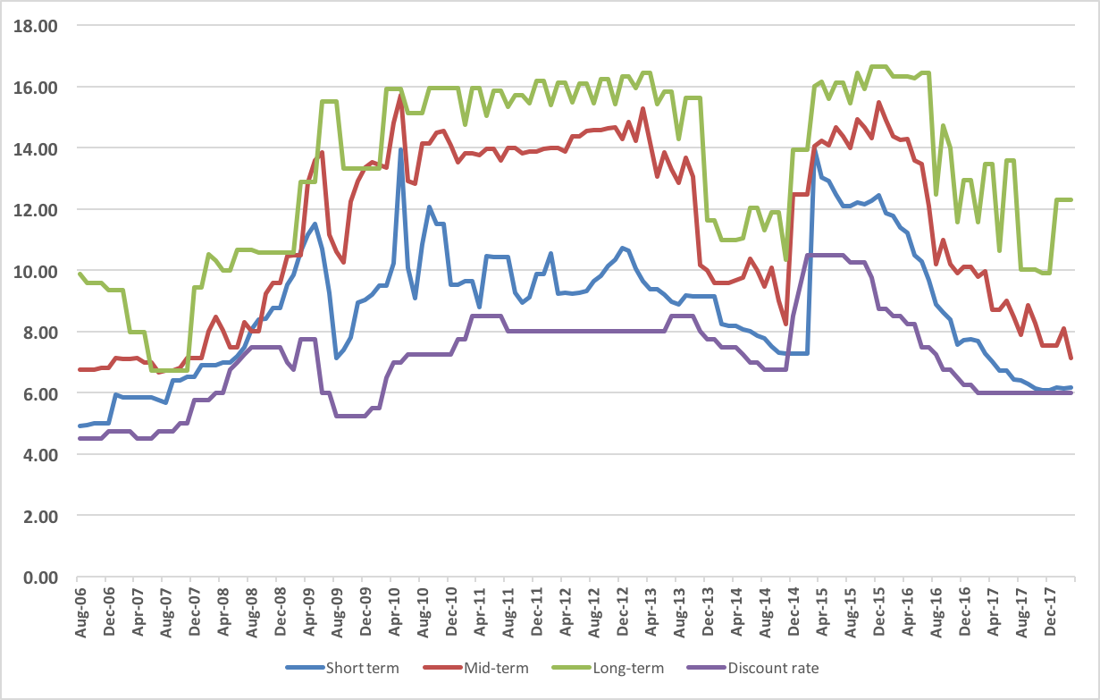Figure-3

**Methodology**

All data have been processed by using Anaconda Python Programming language and Microsoft Excel. For analyzing our data we fit ARDL model, tested cointegration between our variables, forecasted short-term government rate.

To check the non-stationary property, the data are subjected to Augmented Dickey and Fuller test (ADF test). The following regression is for ADF test purpose:

https://lh3.googleusercontent.com/eBSRwxtPFc5xqk7vnbW-MJU96f2NEYaOLf5DK0HEzgYr658hSYoPHuGmwgOIrNXLBfFXTcDQEU8OaDokVZNbaGbPcFdlPZpjUno7CbERGkp_t0UNMJzSkgPjz9EGsunT85ye5QO7

Using this tool we understood that our variables are non-stationary Integrated of order one (I(1)), which means we can calculate cointegration for them. Our next step is to determine whether the variables have a stable and non-spurious cointegrating relationship among themselves and to understand whether they share similar stochastic trends. To make sure that the series are cointegrated we tested the stationarity of the residuals.

After having a 5% p-value significance of accepting the hypothesis we conclude that Discount rate and Short-term Government Bond rate are cointegrated.

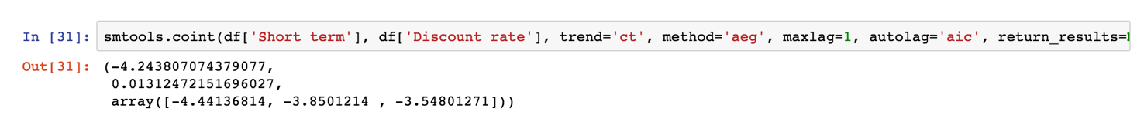

Figure4

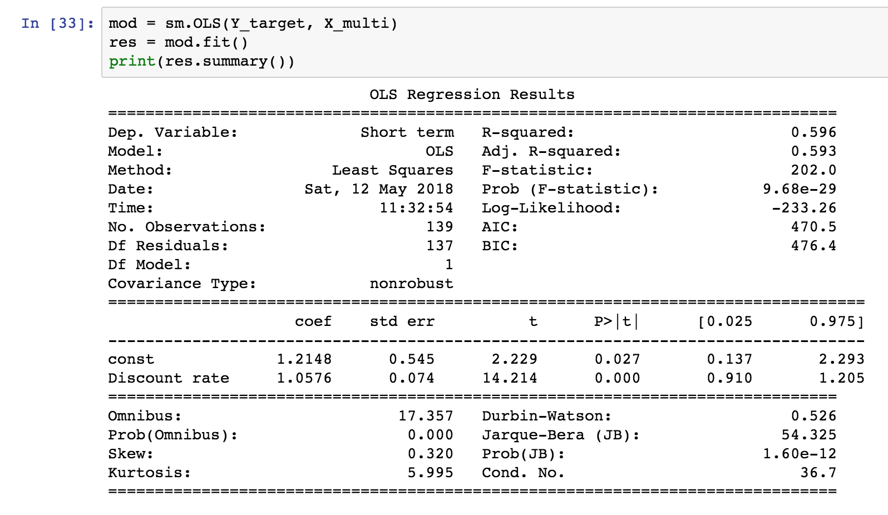  
Figure-5

*ARDL and ARIMA*

We fit different ARDL models and chose the best option with the lowest AIC (331.6) ARDL(2,2) for better prediction of discount rate, where the dependent variable is the first difference of short term rate and the independent variables are its own past lagged values as well as current and past values of discount rate. We concluded that the first and second lags of the discount rate and the same lags of the explanatory variable (short term rate) have the most significance for the dependent variable.

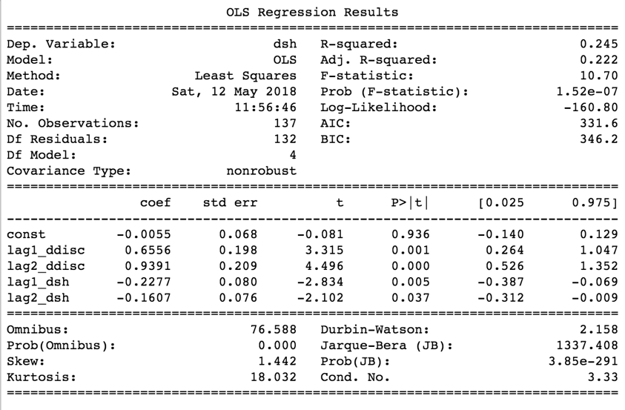  
Figure-6

The last step of our analysis is dedicated to ARIMA model and forecasts for short term rate. We fitted ARIMA (1,1,0) and (0,1,1), which have very close AIC and not significant p-Values. By fitting an ARIMA (1,1,0) model (which had the lowest AIC) we forecasted the future short term rate for the following 6 months. And the results were fluctuating from 6.12 to 6.2.

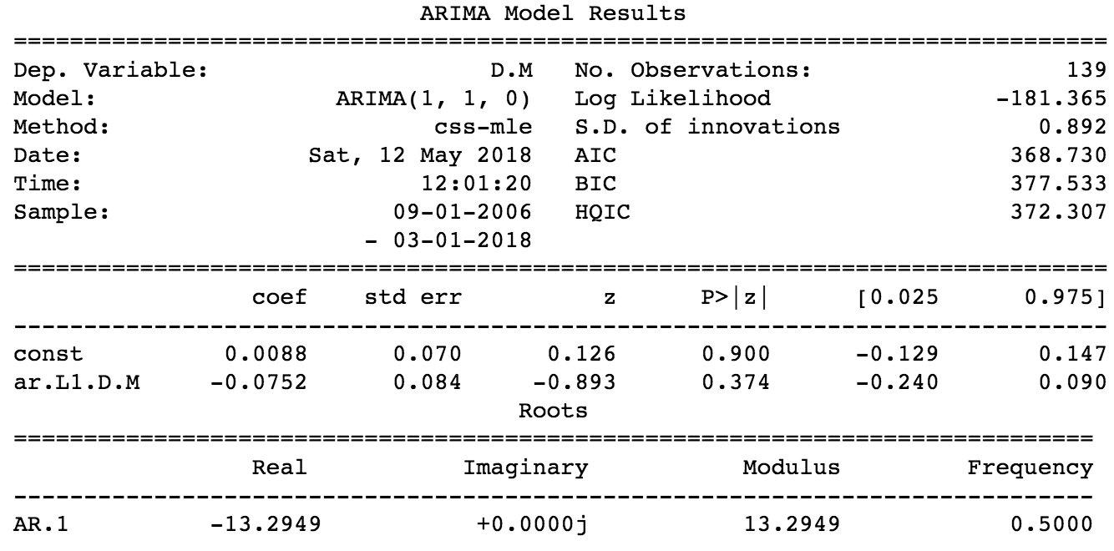

Figure-7

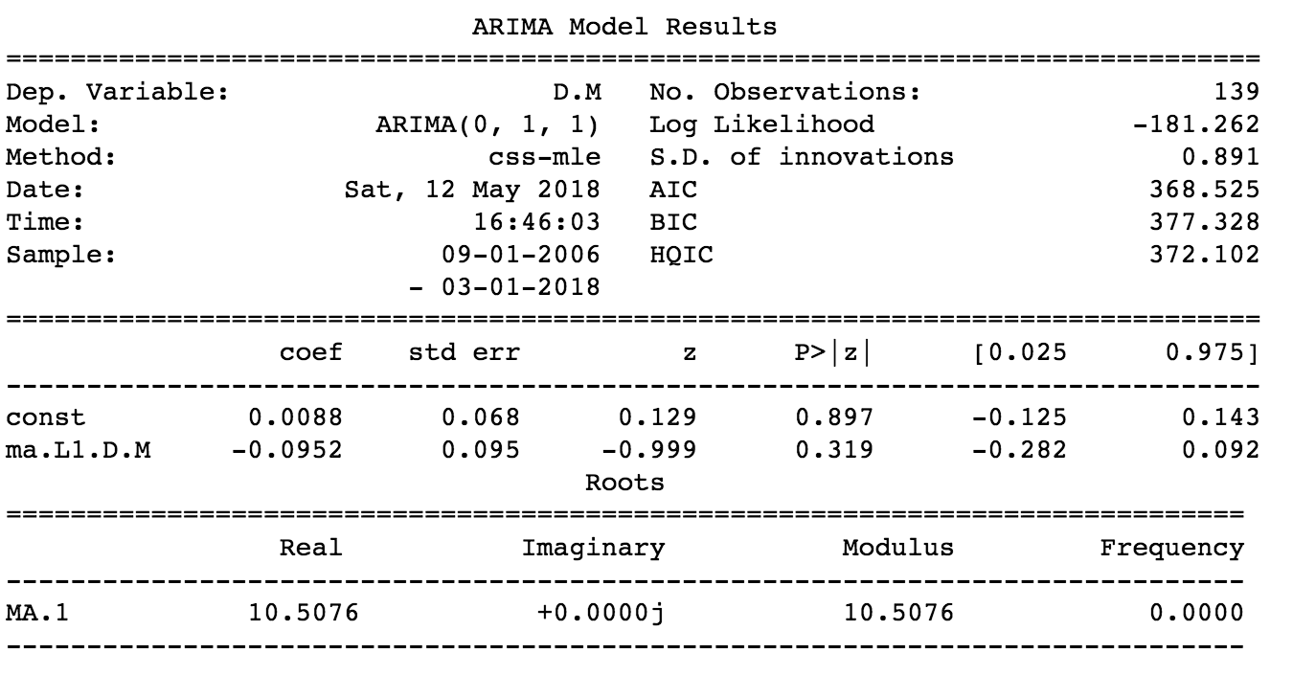

Figure-8

**Conclusion**

This study attempts to investigate the predictive power of discount rate volatility on the returns of stock market in Armenia. The results of unit root test show that all the data series of the variables are integrated of order one. Our procedure of Cointegration test suggests there is cointegrating relationship between the variables. Furthermore, we can see that in the long-run 1 percentage point increase in the discount rate will increase the government bond rate by about 1.057 basis points. Investors should consider the systematic risks exposed by the interest rates during constructing their portfolios and making investment decisions. In our case the rates change with the same pattern and do not contain high level of risk for investors. As it can be concluded from the predictions of discount rate and short term rate there is moderate volatility. This means that future markets will be sustainable.